Multiple-choice section

|  |  |  |  |  |  |  |  |  |  |  |
| --- | --- | --- | --- | --- | --- | --- | --- | --- | --- | --- |
| Question | 1 | 2 | 3 | 4 | 5 | 6 | 7 | 8 | 9 | 10 |
| Answer | D | D | B | C | A | A | B | C | C | A |

Question 1 [9.1]

**D**

The highest power that appears in a quadratic equation is 2 (a squared term). **D** has a term raised to the power of 3.

Question 2 [9.3]

**D**

The constant term indicates to translate the parabola 4 units up.

Question 3 [9.1]

**B**

The graph is a parabola and is an example of a quadratic.

Question 4 [9.3]

**C**

The dilation factor is the coefficient of the term of the second degree. It is represented by *a* in *ax*2 + *bx* + *c*. The coefficient is 5, so the dilation factor is 5.

Question 5 [9.5]

**A**

1 unit to the right *h* = 1

3 units down *k* = -3

The general equation *y* = 2(*x – h*)+ k becomes *y* = 2(*x* – 1)– 3.

Question 6 [9.2]

**A**

*x*(*x* – 2) = 0

*x* = 0

*x* – 2 = 0

*x* – 2 + 2 = 0 + 2

*x* = 2

*x* = 0 or *x* = 2

Question 7 [9.7]

**B**

*y* 

*y* =

*y  x* = *k*

5*y* = 10

*y* = 2

Question 8 [9.4]

**C**

The graph of a circle is represented by the equation *x*2 + *y*2 = *r*2. To find the radius, take the square root of the *r*2 term.  so the radius is 9.

Question 9 [9.6]

**C**

If *a* is directly proportional to *b a**b*

The equation of this relationship is *a* = *kb*.

Question 10 [9.5]

**A**

The power of *x* in the equation for a hyperbola is -1.

Multiple-choice total marks: 10

Short answer section

Question 11 7 marks [9.1]

**(a)** *y* = -*x*2 – 6*x* – 10

|  |  |  |  |  |  |  |  |
| --- | --- | --- | --- | --- | --- | --- | --- |
| ***x*** | -6 | -5 | -4 | -3 | -2 | -1 | 0 |
| ***y*** | -10 | -5 | -2 | -1 | -2 | -5 | -10 |

**(b)**

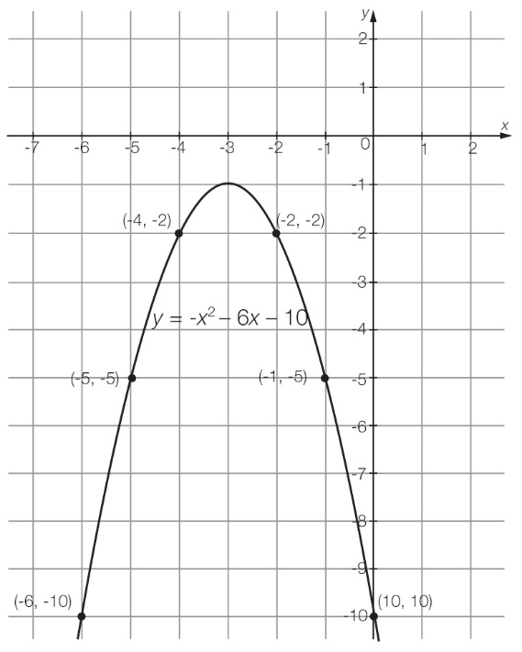

**(c)** From the graph, the turning point is (-3, -1).

Question 12 6 marks [9.1]

**(a)** The turning point is where the graph changes direction. This occurs at (-2, -1).

**(b)** The graph has a minimum turning point.

**(c)** The *y*-intercept is (0, 3).

**(d)** The *x*-intercepts are at (-3, 0) and (-1, 0).

**(e)** The equation of the axis of symmetry is *x* = -2.

Question 13 3 marks [9.2]

|  |  |  |
| --- | --- | --- |
| **(a)** (*x* + 7)(*x* – 4) = 0  *x* + 7 = 0  *x* + 7 – 7 = 0 – 7  *x* = -7  *x* – 4 = 0  *x* – 4 + 4 = 0 + 4  *x* = 4  *x* = -7 or 4 | **(b)** *x*2 + 2*x* = 0  *x*(*x* + 2) = 0  *x* = 0  *x* + 2 = 0  *x* + 2 – 2 = 0 – 2  *x* = -2  *x* = -2 or 0 | **(c)** *x*2 – 25 = 0  (*x* – 5)(*x* + 5) = 0  *x* – 5 = 0  *x* – 5 + 5 = 0 + 5  *x* = 5  *x* + 5 = 0  *x* + 5 – 5 = 0 – 5  *x* = -5  *x* = -5 or 5 |

Question 14 5 marks [9.2]

|  |  |  |
| --- | --- | --- |
| **(a)** *x*2 – 10*x* + 16 = 0  (*x* – 8)(*x* – 2) = 0  *x* – 8 = 0  *x* – 8 + 8 = 0 + 8  *x* = 8  *x* – 2 = 0  *x* – 2 + 2 = 0 + 2  *x* = 2  *x* = 8 or 2 | **(b)** *x*2 + 3*x* = 18  *x*2 + 3*x* – 18 = 0  (*x* – 3)(*x* + 6) = 0  *x* – 3 = 0  *x* – 3 + 3 = 0 + 3  *x* = 3  *x* + 6 = 0  *x* + 6 – 6 = 0 – 6  *x* = -6  *x* = -6 or 3 | **(c)** *x*2 – 2*x* + 1 = 0  (*x* – 1)(*x* – 1) = 0  *x* – 1= 0  *x* = 1 |

Question 15 4 marks [9.3]

**(a)** The graph *y* = *x*2 has been translated up 3 units.

**(b)** The graph *y* = *x*2 has been reflected in the *x*-axis.

**(c)** The graph *y* = *x*2 has been translated 2 units to the left and 4 units down.

Question 16 5 marks [9.4]

*x* min = -4, *x* max = 2, *y* min = -5, *y* max = 1

*x* =  =  = -1

*y* =  =  = -2

centre: (-1, -2)

radius: *r* =  =  = 3

*h* = -1, *k* = -2, *r* = 3

(*x – h*)2 + (*y – k*)2 = *r*2

(*x* – -1)2 + (*y* – -2)2 = 32

equation: (*x* + 1)2 + (*y* + 2)2 = 9

Question 17 3 marks [9.5]

**(a)** an exponential relationship

**(b)** (0, 3.5)

**(c)** an asymptote

Question 18 4 marks [9.5]

**(a)** rectangular hyperbola

**(b)** *a* = 1, *h* = 2, *k* = 1

equation: *y* =  + 1

**(c)** horizontal asymptote is *y* = 1

vertical asymptote is *x* = 2

Question 19 4 marks [9.6]

**(a)** *y* is directly proportional to *x*.

**(b)**  *y* *x*

*y* = *kx*

12 = 3*k*

*k* = 4

28 = 8*k*

*k* = 4

**(c)** Where *x* = 5,

*y* = 5 × 4

* y* = 20

Where *y* = 40,

*x* = 40 ÷ 4

* x* = 10

|  |  |  |  |  |
| --- | --- | --- | --- | --- |
| *x* | 3 | 5 | 7 | **10** |
| *y* | 12 | **20** | 28 | 40 |

Short answer total marks: 37

Extended answer section

Question 20 10 marks [9.1]

**(a)** *h* = -5*t*2 + 20*t*

|  |  |  |  |  |  |
| --- | --- | --- | --- | --- | --- |
| *t* | 0 | 1 | 2 | 3 | 4 |
| *h* | 0 | 15 | 20 | 15 | 0 |

**(b) (i)** (2, 20)

**(ii)** (0, 0) and (0, 4)

**(iii)** (0, 0)

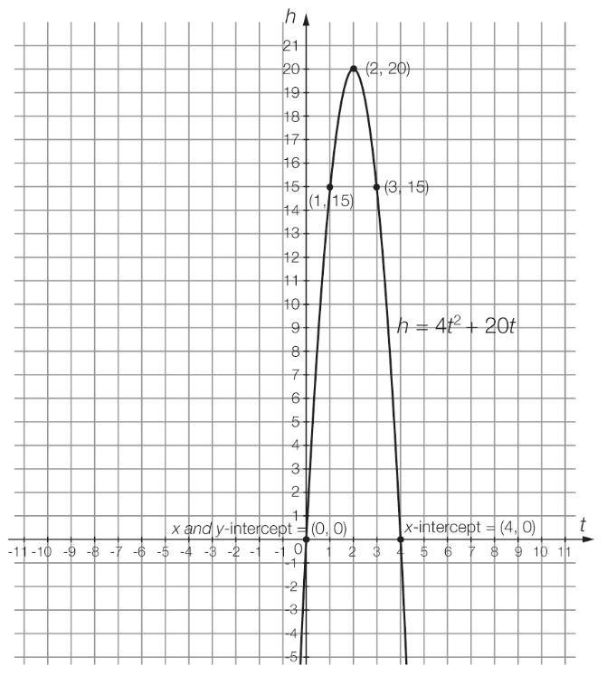

**(c)** From the graph, the maximum height of the ball is 20 m.

**(d)** at 2 seconds

**(e)** From the graph, the ball hits the ground at 4 seconds.

**(f)** at 1 second and again at 3 seconds

Question 21 16 marks [9.4]

**(a)** (*x* – 3)2 + (*y* – 3)2 = 4

centre: (3, 3)

**(b)** radius: √4 = 2

**(c)** *x* min = 1, *x* max = 5, *y* min = 1, *y* max = 5





point *A*: (3, 1); point *B*: (1, 3); point *C*: (3, 5); point *D*: (5, 3)

**(e)**

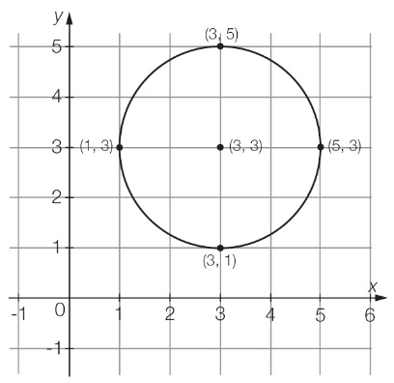

**(f) (i)** (5, 1) – outside

**(ii)** (2, 2) – inside

**(iii)** (4, 3) – inside

**(iv)** (1, 2) – outside

Question 22 6 marks [9.7]

**(a)** The relationship between *x* and *y* is inversely proportional because as *x* is increasing, *y* is decreasing.

**(b)** 1  20 = 20

2  10 = 20

5  4 = 20

10  2 = 20

*****k* = 20

**(c)** *y* 

*y* = 

*y* = 

**(d)**

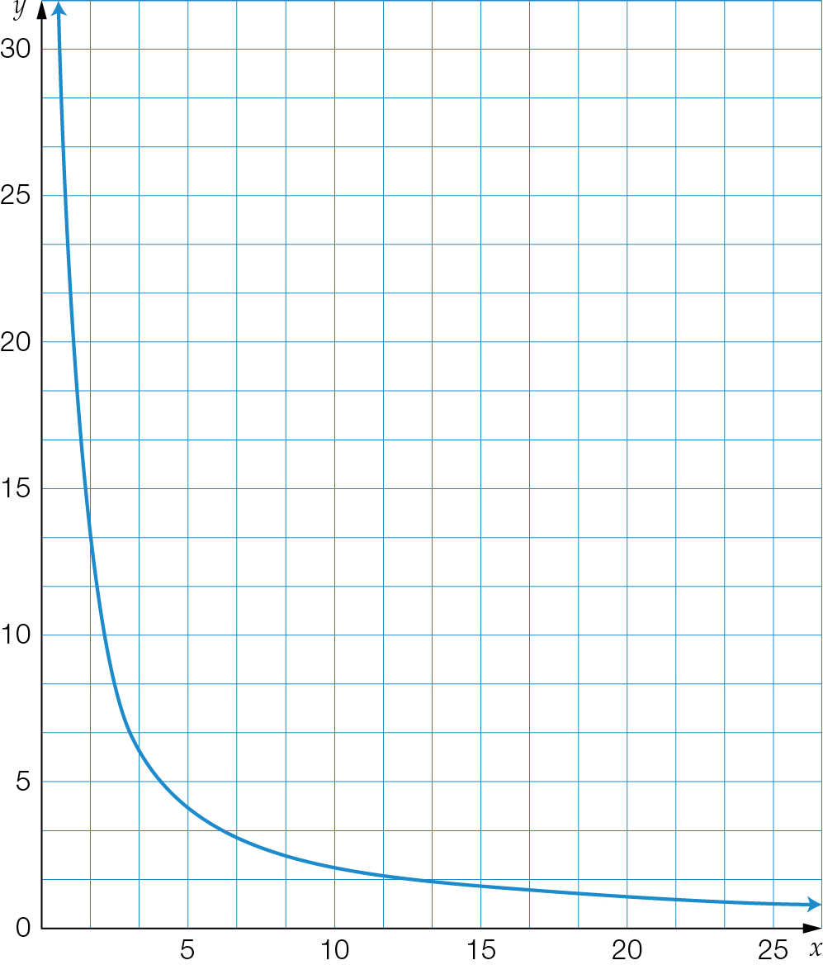

**(e)** Where *x* = 20:   
*y* = 

*y* = 1

Extended answer total marks: 32

TOTAL test marks: 83